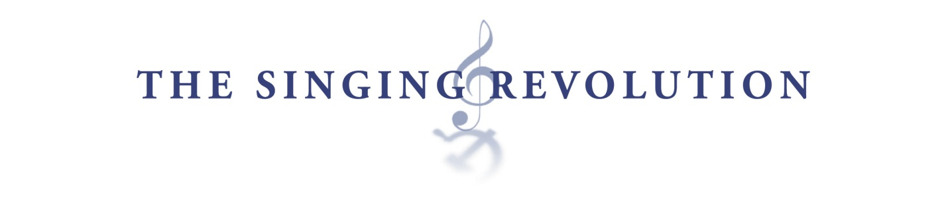Subjects: English Language Arts / Music & Art

The Role of Free Speech in Music and the Arts

Aim / Essential Question
How does free speech play an important role in the creation of music, art, and culture?

Overview
Music and the arts continue to be a celebration of free speech and have played an important role in cultural endurance. Students will be asked to consider how the free speech of Western culture helped the Estonian people to endure and how gaining some free speech rights helped win Estonia independence.

Materials & Technology
- Article: “SC attorney general won’t let libraries have ‘offensive’ CDs”
(below)
- Class set of Free Speech in Music and the Arts: Discussion Questions handout
(below)
- The Singing Revolution (Chapter 5)
(from Disc One / Chapters)
- The Role of Finnish TV, Voice of America & Radio Free Europe
(from Disc Two / Section 2: 1957-1986: The Stagnation Years)
- Class set of First Amendment Journal
(below)
- Any DVD-compatible player that will allow distinct chapters to be shown
- A television or video projection unit

Lesson Time: One 50-minute class period.

Objectives
Students will:
- Identify positive and negative ramifications of free speech.
- Evaluate the personal desire for freedom of speech, based on the video clips from The Singing Revolution.
- Discuss and debate the impact of free speech on Estonian independence.
- Reflect on the role of free speech in their own lives.

Instruction
Opening: Bell Ringer / Do Now
Read the text of the First Amendment aloud to students: “Congress shall make no law respecting an establishment of religion, or prohibiting the free exercise thereof; or abridging the freedom of speech, or of the press; or the right of the people peaceably to assemble, and to petition the Government for a redress of grievances.”

Next, share with students the attached news article from, www.firstamendmentcenter.org/news. Either read this article aloud or distribute copies to students. Inform the students that there have been other states considering similar bans, as well as multiple congressional hearings regarding profanity and violence in music and considering various levels of censorship. Encourage a brief debate based on the article. Did South Carolina violate First Amendment rights by banning controversial materials from public libraries? What would be the benefit or rationale for limiting such material?

Activities
- After the warm-up debate, have students individually list some pros and cons of free speech in the chart on the Discussion Questions handout, as well as address the associated discussion questions.
- Explain to students that the free speech rights of Estonians were violently repressed under Soviet Rule until the 1980s when Gorbachev began to institute glasnost and perestroika. Show students Scene 5: “Gorbachev and Early Protests” from Disc 1 of The Singing Revolution (34:40-43:08).
- Have students think-pair-share to answer the question, “How were glasnost and perestroika similar to the American First Amendment, and how might these policies have benefited oppressed Estonians?” Students should first answer the question on the handout, and then share their answer with a partner. Call on several students to report to the class.
- Show students “The Role of Finnish TV, Voice of America & Radio Free Europe” (6:20) from Disc 2 of The Singing Revolution.
- Students think-pair-share again to answer the question, “How was the free speech of other nations encouraging to oppressed Estonians? What effect might this have had on Estonians desiring revolution?”

Close: Application / Summary
Distribute the First Amendment Journal to students and allow several minutes to write. If students do not finish, they may do so for homework.

(archived at www.firstamendmentcenter.org/news)

S.C. attorney general won't let libraries have 'offensive' CDs
By The Associated Press
06.20.04 -Reprinted with permission
COLUMBIA, S.C. — Thousands of free music CDs from a nationwide price-fixing settlement are headed to South Carolina libraries, but state Attorney General Henry McMaster says a few artists won't make it to the shelves.
Rapper Eminem and actors Cheech and Chong, known for their dope-smoking comedy bits, are among artists removed from the distribution list because of offensive material, McMaster's spokesman Trey Walker said last week.
"There was not a requirement to vet the titles, but we took it upon ourselves," Walker said on June 15. "Other states did that as well."
Walker said members of McMaster's staff went through the list of artists and recommended ones to eliminate.
"Clearly, some things are not appropriate for minors to have access to," he said.
Denyse Williams, executive director of the South Carolina office of the American Civil Liberties Union, thinks McMaster's action violates the law.
"When the chief law enforcement officer decides to make a wholesale decision, it's prior restraint," she said.
Walker said the attorney general had the right to make such decisions under the terms of the settlement.
The multistate lawsuit against the recording industry alleged record companies conspired to illegally raise the prices of prerecorded music products by implementing Minimum Advertised Price policies, which was in violation of state and federal laws.
Each of the more than 3 million individuals who registered a claim in the lawsuit — including 36,525 South Carolinians — received a $13.76 settlement check.
The record industry also will distribute about $75 million in CDs to states.
From classical to hip-hop and bluegrass to electronica, the music titles South Carolina libraries expect to get are diverse. The South Carolina State Library will distribute the CDs to 34 library systems across the state by the first week of July.
Distribution is based on population.
The selection process doesn't bother Kershaw County Library Director Penny Harvey.
"We'll go from nothing to something," Harvey said. "We're looking forward to making it available to the public and encouraging them to use it, and hopefully it will be like gangbusters."
Name _________________ Date __________________
Class _________ Period ___ Teacher _______________
Free Speech in Music and the Arts
Discussion Questions

Why is free speech important to an artist or a musician? Could free speech in music or art be offensive or troublesome? List some pros and cons of free speech in the chart below.

Pros Cons

Do you really have complete free speech under the First Amendment? What limitations are there on your freedom of speech?

How could those in authority gain power by limiting the free speech rights of others?

After watching the first clip from The Singing Revolution:

How were glasnost and perestroika similar to the American First Amendment, and how might these policies have benefited oppressed Estonians?

After watching the second clip from The Singing Revolution:

How was the free speech of other nations encouraging to oppressed Estonians? What effect might this have had on Estonians desiring revolution?

Journal

United States Constitution: Amendment I
Congress shall make no law respecting an establishment of religion, or prohibiting the free exercise thereof; or abridging the freedom of speech, or of the press; or the right of the people peaceably to assemble, and to petition the government for a redress of grievances.
Many Americans hold their First Amendment right to freedom of speech as paramount in a free and democratic society. What does the First Amendment mean to you? Why is it important in your life, and what would America be like without it? Are there any downsides to free speech? Is it important that artists and musicians be allowed to create without fear of censorship?

