Subject: Music & Art

Conflict in Art: An Unlikely Muse

Aim / Essential Question
How does conflict inspire meaningful music and other lasting art?

Overview
During times of violent conflict and cultural oppression, music and art take on a deeper meaning and enduring significance. In this lesson students will examine the role of conflict in art by comparing the “Star-Spangled Banner” and “Ilus maa/Beautiful Land” from The Singing Revolution.

Materials & Technology
- Class set of The Role of Conflict in Art question sheet
(below)
- Ilus maa / Beautiful Land video clip
(from Disc Three / Section 5: Song Festival / Laulupidu)
- Class set of the lyrics to Francis Scott Key’s Star-Spangled Banner
(below)
- Class set of the lyrics to Ilus maa / Beautiful Land
(from Disc Three / Section 5: Song Festival / Laulupidu / Printable Documents)
- Class set of 3-2-1 Summary Chart
(below)
- Guernica Painting Website: http://www.pbs.org/treasuresoftheworld/a_nav/guernica_nav/main_guerfrm.html
- Francis Scott Key Biography and Creation of the national anthem:
http://www.star-spangled-banner.info/who-wrote/
- History of The Singing Revolution:
http://www.singingrevolution.com/cgi-local/content.cgi?pg=3&p=19
- Computer with projection capability
- Any DVD-compatible player that will allow distinct chapters to be shown
- A television or video projection unit

Lesson Time: One 50-minute class period.

Objectives
Students will:
- Recognize and explain the role of conflict in various examples of art.
- Compare and contrast two patriotic songs inspired by conflict.
- Distinguish and list lyrics which relate to conflict.

Instruction
Opening: Bell Ringer / Do Now / Anticipatory Set
- Show students an image of Pablo Picasso’s “Guernica” painting (available at: http://www.pbs.org/treasuresoftheworld/a_nav/guernica_nav/main_guerfrm.html). Ask students to independently list and describe some of the images they see in the painting. After a few minutes, ask students to answer the question, “What do you think was Picasso’s message in this painting?” on the question sheet.
- Allow students to share responses as a whole group. Then share the brief background information about the painting from the website. Use this sharing as a springboard into a discussion on the role of conflict in meaningful art.
Activities
- In a group discussion, ask students what they know about the history of Francis Scott Key’s “Star-Spangled Banner” and how it came to be America’s national anthem.
- Share the brief bio and anthem history from: http://www.star-spangled-banner.info/who-wrote/
- Explain some brief background information about the song festival and Estonians gaining independence from the Soviet Union. Important details include that the song festival has been held periodically for over 100 years, and that the patriotic songs helped Estonians to maintain a united sense of culture in the face of occupation and cultural oppression. More background information on the song festival can be found at: http://www.singingrevolution.com/cgi-local/content.cgi?pg=3&p=19
- Show students the clip of the 2004 song festival performance of: “Ilus maa/Beautiful Land.”
- Distribute copies of the lyrics of “The Star-Spangled Banner” and “Ilus maa/Beautiful Land.” Students should complete the discussion and comparison questions on the question sheet. They may do so individually, with partners, or in small groups.
- When students have finished answering the questions, they should individually answer the final question, “What role does conflict have in creating lasting art?” If they do not finish their chart, they may do so for homework.
Close
Application / Summary
Students complete a 3-2-1 Chart by listing three pieces of art discussed in the lesson which were inspired by conflict, two reasons why conflict contributes to meaningful art, and one other piece
of art, (could be a song, statue, painting, sculpture, etc.) inspired by conflict which was not discussed in class.

Name __________________________ Date ____________________________
Class ___________ Period _________ Teacher _________________________

The Role of Conflict in Art

1. What individual images do you see in Picasso’s “Guernica?” List three or more.

2. What do you think Picasso’s message or theme was in painting “Guernica?”

Read the lyrics to Francis Scott Key’s “The Star-Spangled Banner.” Answer the following:

3. What words and phrases indicate that this song was inspired by conflict?

4. What role did conflict have in the creation of this song?

5. Why is this song so powerful to the American people?

Read the lyrics to “Ilus maa/Beautiful Land.” Answer the following:

6. What words and phrases indicate that this song was inspired by conflict?

7. What role did conflict have in the creation of this song?

8. Why is this song so powerful to the Estonian people?

Directions: In the following chart, compare and contrast “The Star-Spangled Banner” with “Ilus maa/Beautiful Land.” List similarities on the “Compare” side and differences on the “Contrast” side.

Compare | Contrast

What role does conflict have in inspiring lasting art? Answer in several thoughtful sentences.
__________________________ ______________________________________________________________________________

The Star-Spangled Banner Lyrics
By Francis Scott Key — 1814

Oh, say can you see by the dawn's early light
What so proudly we hailed at the twilight's last gleaming?
Whose broad stripes and bright stars thru the perilous fight,
O'er the ramparts we watched were so gallantly streaming?
And the rocket's red glare, the bombs bursting in air,
Gave proof through the night that our flag was still there.
Oh, say does that star-spangled banner yet wave
O'er the land of the free and the home of the brave?
On the shore, dimly seen through the mists of the deep,
Where the foe's haughty host in dread silence reposes,
What is that which the breeze, o'er the towering steep,
As it fitfully blows, half conceals, half discloses?
Now it catches the gleam of the morning's first beam,
In full glory reflected now shines in the stream:
'Tis the star-spangled banner! Oh long may it wave
O'er the land of the free and the home of the brave!
And where is that band who so vauntingly swore
That the havoc of war and the battle's confusion,
A home and a country should leave us no more!
Their blood has washed out their foul footsteps' pollution.
No refuge could save the hireling and slave
From the terror of flight, or the gloom of the grave:
And the star-spangled banner in triumph doth wave
O'er the land of the free and the home of the brave!
Oh! thus be it ever, when freemen shall stand
Between their loved home and the war's desolation!
Blest with victory and peace, may the heav'n rescued land
Praise the Power that hath made and preserved us a nation.
Then conquer we must, when our cause it is just,
And this be our motto: "In God is our trust."
And the star-spangled banner in triumph shall wave
O'er the land of the free and the home of the brave!

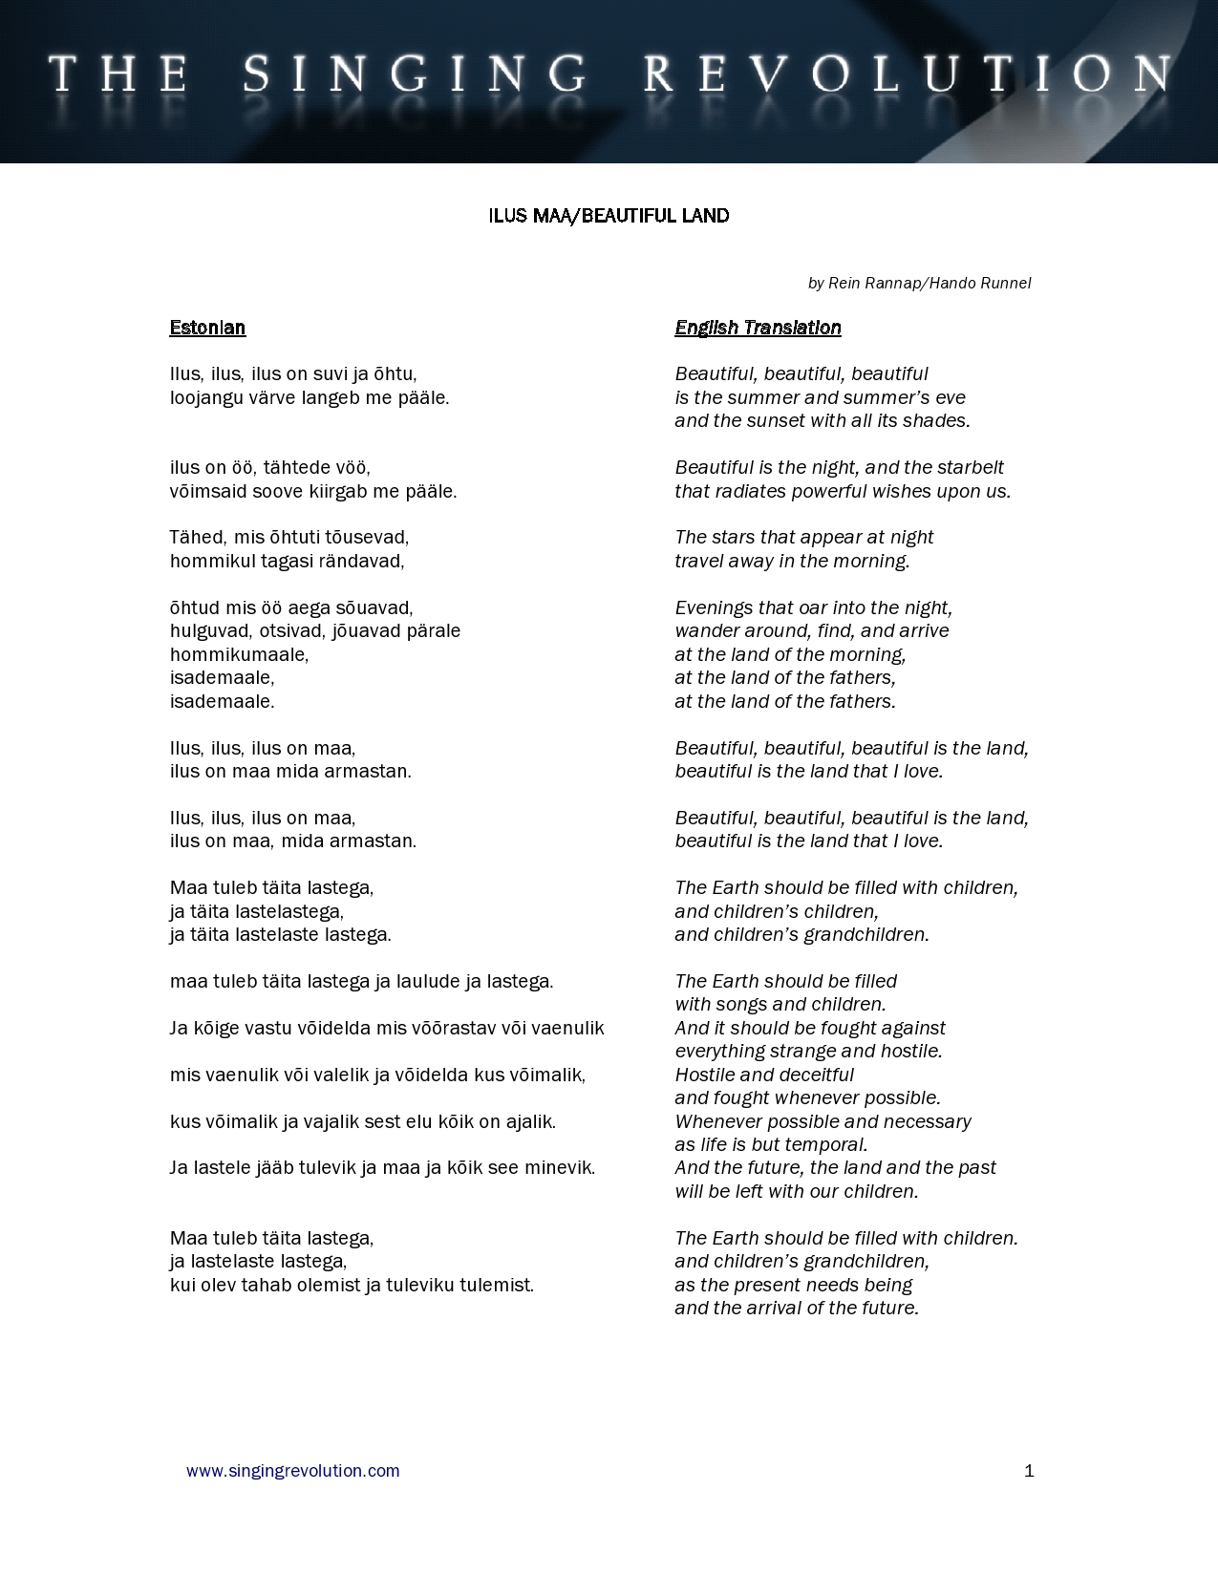

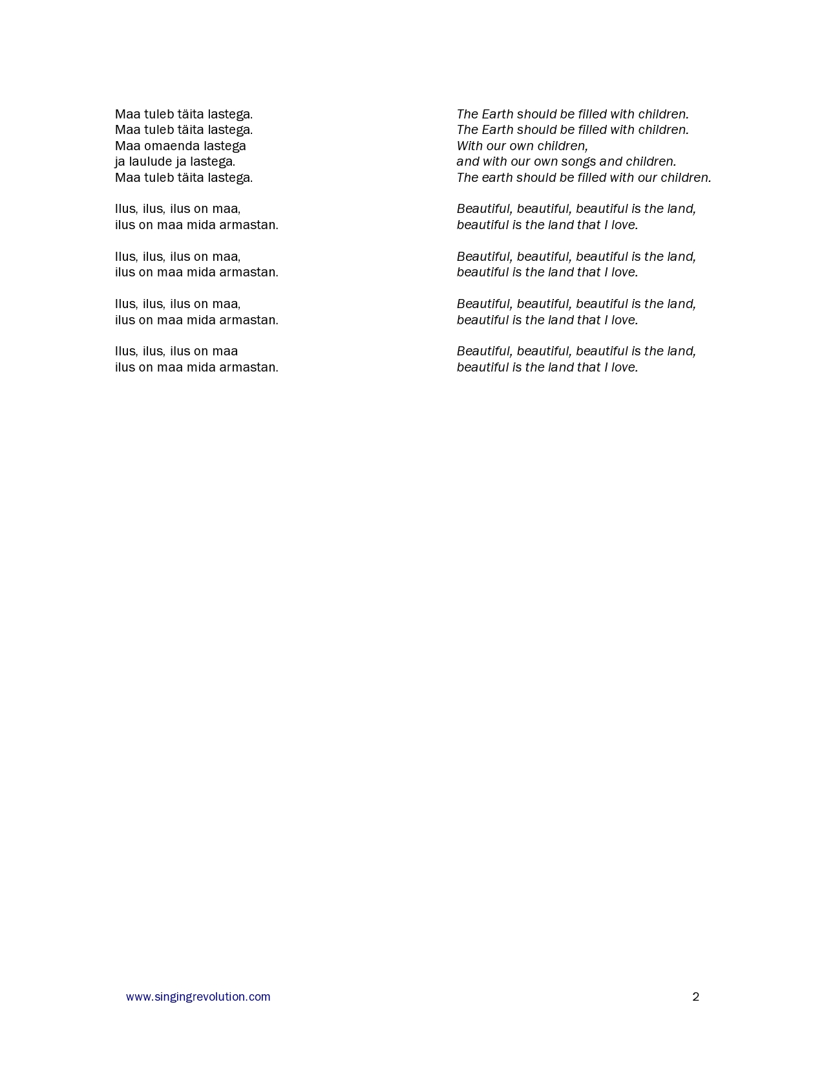

Name _________________ Date __________________
Class _________ Period ___ Teacher _______________

3-2-1 Summarizer

List three pieces of art (from class) which were inspired by conflict:

1.

2.

3.

List two reasons why conflict contributes to meaningful art:

1.

2.

List one other piece of art (song, statue, painting, sculpture, etc.) which was inspired by conflict:

1.

