Subjects: History / Geography

The Estonian Barometer:
A Geopolitical Study of Estonia through Historical Maps

Aim / Essential Question
How has Estonia’s geography impacted its geopolitical value throughout history?

Overview
Students will create a physiographic map of Eastern Europe, compare it to historical maps in a gallery walk, and answer guiding questions on a handout. They will then use their collected information to produce a timeline.

Materials & Technology
- Slide show presentation of activities
(from www.izzit.org)
- Printed color copy of slide show slides #8 - #19
- Class set of student handout
(below)
- Estonia PowerPoint Maps with text
(from Disc Three / Section 6: Maps & Chronologies, Filmmakers’ Interview / Printable Documents)
- World atlas or textbook maps
- Computer with projection capability

Lesson Time: Four 50-minute class periods.

Objectives
Students will:
- Create a map with both physical and political elements of Eastern Europe.
- Observe, collect, and compare information from historical maps.
- Evaluate the extent of a nation’s liberty at various historical periods.
- Create a spectrum upon which to measure liberty.
- Write a summative essay bringing together the concept of Estonian independence and geography.

Instruction
Day 1
Opening: Bell Ringer / Do Now
Have students respond to bell ringer question located on slide #2. Answers will vary. (5 min.)

Activities
- Project slide # 3. Discuss how the bell ringer is an example of geography impacting value of a place, (e.g., having more snow and being on higher ground gives you a fighting advantage).
- Have students copy notes A-D on their handouts. (25 min.)

- Project slide # 4. Have students draw and label the countries, waterways, and landforms of Eastern Europe listed on page 2 of the handout. Students will work on this assignment for the remainder of class, and should finish it for homework.

Day 2
4. Show students slide #5. Students will use their maps of Eastern Europe and their notes to respond to questions of Estonia’s geographic importance on page 3 of their handout. (30 min.)
5. Allow students to share examples of their summaries from page 3 of the handout. Discuss with the students how their summaries might suggest that Estonia is a desirable place and thus led to habitation, conflict, and invasion. (15 min.)
- Have students complete the exit ticket question in which they theorize whether Estonia has been a place of habitation, conflict, and invasion as a result of its geography. Show slide #6. (5 min.)

Day 3
Students will conduct a gallery walk of historical maps (also located on slides #8 – #19). The printed maps should be posted around the classroom.
7. Show slide #7, and tell the students to open their handout to page 4. Depending on class size, have students work in pairs or groups of three viewing the printed maps. Tell the students they will follow the instructions on slide #7 for each map they view. The students will then observe change and continuity within each map. Write a short summary of the paragraphs found on each map, and rate Estonia’s freedom. Review the directions using slide #7 before beginning the gallery walk. After 4 minutes, have students move to the next map and repeat the process until they return to their original map. (48 min.)

Day 4
Close: Application / Summary
8. Discuss findings from day 3 with students. Ensure that students understand Estonia had a long history of independence until the 13th Century and did not become free again until after World War I. After twenty years of independence, they were occupied again by both the Soviet Union and Nazi Germany, and were not free again until the fall of the Soviet Union. (15 min.)
- Show slide #20. Assign students an essay in which they use their completed handout to answer the following prompt:
- Estonia’s geography has impacted its geopolitical value—its desirability—which has made it a target throughout history. Use information from your Freedom Barometer notes, Eastern Europe physiographic map, and handout notes to prove this thesis.

Homework
Students will complete their essay for homework.

Name _____________________________ Date ____________________________
Class _____________ Period ___________ Teacher _________________________
Bell Ringer: “Snowball Fight”
__________________________________________________________________________________________________________________________________________________________________________________________________________________________________________________________________________________________________________________________________________________________________________________________________________________________

The Estonian Barometer
Notes:

Does geography impact the value of a place to itself or others?

A___________________________________________________________________________________________________________________________________________________________________________________________________________________________________________________
B___________________________________________________________________________________________________________________________________________________________________________________________________________________________________________________
C______________________________________________________________________________________________________________________________________________________________________________________ _____________________________________________________________
D___________________________________________________________________________________________________________________________________________________________________________________________________________________________________________________

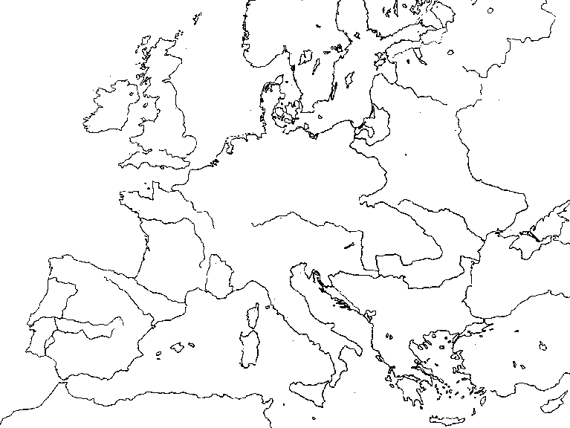
Using physical and political maps in a world atlas or textbook, map the following European countries and physical features:

Countries: Estonia, Russia, Germany, Poland, Hungary, Latvia, Finland, Sweden, Lithuania, Belarus, Ukraine, Hungary, Romania, Bulgaria.

Bodies of Water: Baltic Sea, Gulf of Finland, Lake Peipus, Gulf of Riga, North Sea.

Landforms: Northern European Plain, Ural Mountains, Alps, Carpathian Mountains.

Create a key to match the following color coding: Blue-water, Brown-mountains, Green- plains, Red-national borders. Use these colors in your map.
Name _________________ Date __________________
Class _________ Period ___ Teacher _______________
For each of your notes A-D, explain how the geography of Estonia might impact its value. You will need to:

- Review the letter A notes
- See how Estonia meets/does not meet the example(s) found in those notes by comparing them to your map.
- Write down your findings on the matching line below.
- Repeat the process for letters B-D.
- Write a summary of your findings. Be sure to include a statement of Estonia’s geographic importance. You may choose to affirm or deny its geographic importance. Whatever you choose to do, you must back up with evidence from your notes!
A______________________________________________________________________________________________________________________________________________________________________________________
B______________________________________________________________________________________________________________________________________________________________________________________
C______________________________________________________________________________________________________________________________________________________________________________________
D______________________________________________________________________________________________________________________________________________________________________________________
Summary:
__________________________________________________________________________________________________________________________
___________________________________________________________________________________________________________________________________________________________________________________________________________________________________________________________________________________________________________________________________________________________________________________________________________________________________________

Exit Ticket: Do you think Estonia’s history of conflict and invasion is a result of its geographic location? Why? _________________________________________________________________
_________________________________________________________________
_________________________________________________________________
_________________________________________________________________
_________________________________________________________________
Name ___________________________
Freedom Barometer
As you view each map, write a summary below the appropriate date on the chart, and rate Estonia's level of freedom from 1 to 10.
1 indicating no freedom, 10 absolute freedom. Shade in the boxes on the chart to reflect your rating.
Level of Freedom | 10
 | 9
 | 8
 | 7
 | 6
 | 5
 | 4
 | 3
 | 2
 | 1
 |  | 180 A.D. | 1180 | 1223 | 1270 | 1572 | 1648 | 1721 | 1925 | 1940 | 1942 | 1949 | 1997
 |  | Notes: | Notes: | Notes: | Notes: | Notes: | Notes: | Notes: | Notes: | Notes: | Notes: | Notes: | Notes:

