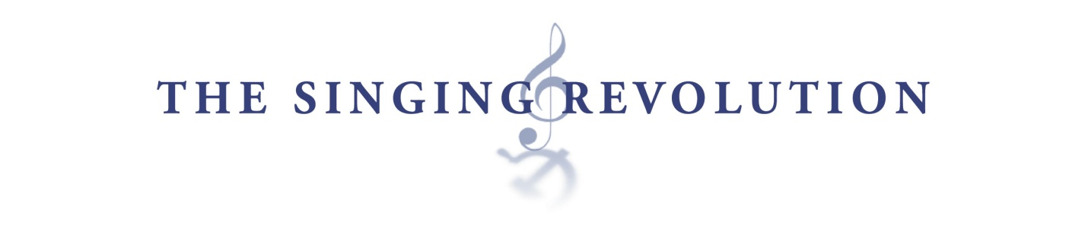Subjects: History

The Molotov-Ribbentrop Pact: The Document of Occupation
and Liberation

Aim / Essential Question
What role did the Molotov-Ribbentrop Pact play in the history of Estonia? How did a “non-aggression” pact between the Nazis and the Soviets lead to the occupation and liberation of Estonia?

Overview
The Molotov-Ribbentrop Pact was an agreement between the Nazis and the Soviets that contained a secret protocol. This secret would be the basis for Soviet occupation in the Baltic States for the next
50 years. This lesson will show the progression of events that led to the occupation and eventual independence of the Baltic States.

Materials & Technology
- Class set of Bell Ringer / Do Now activity handout
(below)
- Class set of one map for homework assignment.
(from Disc Three / Section 6: Maps & Chronologies, Filmmakers’ Interview /
Printable Documents)
- Comments on the Atlantic Charter/Yalta/ Hungarian Uprising
(from Disc Two / Section 1: 1939-1956: The Soviet & Nazi Occupations)
- Details on the Hirve Park Demonstration
(from Disc Three / Section 4: 1987-1991: The Singing Revolution)
- The Baltic Bloc-MRP Acknowledged in Moscow
(from Disc Three / Section 4: 1987-1991: The Singing Revolution)
- Slide show presentation of activities
(from www.izzit.org)
- Computer with projection capability
- Any DVD-compatible player that will allow distinct chapters to be shown
- A television or video projection unit

Lesson Time: One 50-minute class period. (Note: Videos will take up 21 minutes.)

Objectives
Students will:
- Create a timeline of events that will show the significance of the Nazi violation of the MRP.
- Analyze the legality of international agreements and their impact on other countries.
- Evaluate the status of Eastern Europe had the MRP been adhered to by the Germans.

Instruction
Opening: Bell Ringer / Do Now
(A handout for this task is located at the end of the lesson plan.)
Write a secret agreement between you and someone at school. What kind of agreement would you want to make with a friend, or adversary, or teacher? As you write the secret agreement, do so knowing that nobody will ever find out what your secret agreement is. Give the students an example of such an agreement. A teacher taking cash from a student for a good grade might be a good example. (5 minutes)

Ask the students:
- To share their agreements with the class.
- To briefly explain the consequences of the secret being exposed.
- Who gained from the agreement? Who got taken advantage of?

Activities
- Begin the slide show presentation.
Slide #2 explains the agreement.
- Slide #5 explains the secret protocol between Germany and the Soviets.
- Slide #6 shows some of the highlights of the 1939 negotiations with Stalin and Molotov. Particular attention should be paid to Stalin’s first comments. (The full text can be found on disc 2.)
- Slide #7 highlights the Nazi aggression.
- Slide #8 introduces the Atlantic Charter and the birth of the United Nations.
- Slide #9 explains how the Soviet Union became a de-facto ally of the U.S. and Britain.
- Slides #10 & #11 highlight the beginning of the end for Germany.
- Slides #12 & #13 highlight the Yalta Conference and the “carving up” of Europe.
- Disc 2 video is introduced. (Marju Lauristin Comments (3:45-4:29) from Disc Two / Section 1: 1939-1956: The Soviet & Nazi Occupations / Comments on the Atlantic Charter/Yalta/ Hungarian Uprising) It would be best to have the video ready to go at the 3:45 mark to keep the lesson flowing.
- Return to the slide show presentation.
- Slide #15 explains why the Soviet leaders would want to surround themselves with, “satellite nations,” to create a buffer against further aggression.
- Disc 3 video is introduced. (The Baltic Bloc-MRP Acknowledged in Moscow from Disc Three / Section 4: 1987-1991: The Singing Revolution) This shows the Hirve Park demonstrations as well as the process that led to Moscow’s acknowledgment of the secret protocols, which led to the MRP’s nullification.
- Slide #19 shows some key moments in the recognition of Estonia as an independent state, from Iceland to the United Nations.

Close: Application / Summary
Discuss the implications of the Nazis’ decision to invade the Soviet Union during the winter.
  - What effect did “General Winter” have on the war?
  - Could we make the assumption that the weather played an essential role in the first documented retreat of the Nazi army?
  - Was that moment the “beginning of the end” of the Nazi aggression?
  - Develop a timeline that includes the year and month of the progression, and how weather conditions played a role in the conflict.

Discuss the implications of international agreements between countries.
- Who should decide if the agreements are legal?
- What if agreements between two countries cause social or economic harm to other sovereign countries?
- What if the agreements are specifically created to do harm to another country?
- Who decides what is right and wrong between countries?
- If Germany honored the MRP, and cooperated with the Soviet Union in their invasion and occupation of Europe, what would Europe look like today? Hypothesize where the borders would be and what Europe would look like today.

Homework
Hypothesize:
- What would Europe have looked like if Germany did not attack the Soviet Union and violate the MRP?
- What do you think Europe would look like today? Give students a map of Europe and have them draw borders of the “German Empire,” and the “New Soviet Union,” under the assumption of cooperation and the secret protocol.

Name _____________________________ Date ____________________________
Class _______________ Period _________ Teacher _________________________

Create a secret agreement with another student or teacher in school. Assume that the agreement will never be made public.

Here is an example of a secret agreement:

Mr. Smith and his student Thomas reached a secret agreement that Thomas would get an A for every assignment he did, as long as each assignment came with a $25 payment. Thomas was relatively wealthy and could afford to pay that fee. As long as each party kept the agreement secret, there would be “no harm done” to anyone else.

Your turn...

______________________________________________________________________________

______________________________________________________________________________

______________________________________________________________________________

______________________________________________________________________________

______________________________________________________________________________

______________________________________________________________________________

______________________________________________________________________________

______________________________________________________________________________

______________________________________________________________________________

______________________________________________________________________________

______________________________________________________________________________

______________________________________________________________________________

______________________________________________________________________________

______________________________________________________________________________

______________________________________________________________________________

______________________________________________________________________________

