Subject: History

The Singing Revolution Document Based Question (DBQ) Essay

Aim / Essential Question
Based on the documentary The Singing Revolution, were the Estonians justified in their claim of independent national sovereignty from the Soviet Union?

Overview
Students will watch The Singing Revolution, complete a series of document analysis activities, and write an essay that answers the Aim/Essential Question.

Materials & Technology
- The Singing Revolution (entire film)
(from Disc One / Play Film)
- Class set of the DBQ packet
(below)
- Any DVD-compatible player
- A television or video projection unit

Lesson Time: Four 50-minute class periods.

Objectives
Students will:
- Identify key events and write notes while observing a documentary film.
- Analyze historical documents and respond to guiding questions.
- Write a persuasive essay that answers the essential question, using the included documents and additional information from the film/student-generated notes.

Instruction
Days 1 and 2
Opening: Bell Ringer / Do Now
- Tell students they will watch a film about an Eastern European country, Estonia, and its path to independence.
- Write Aim/Essential Question on the board.
- Tell students to take notes addressing the essential question.
- Show The Singing Revolution in its entirety. Note: It is essential that the students have seen the film before beginning the DBQ activities for them to have an understanding of the documents they will be working with.

Day 3
- Give students a copy of the DBQ packet. Have them complete all included questions. Tell students they will use the packet and their notes from the film to write their rough draft of the persuasive essay the following day. Allow students to take home the packet to complete for homework.

Day 4
- Discuss student responses to DBQ question, ensuring comprehension of the documents. Have students begin their rough draft essays using the DBQ packet and film notes. Provide students with guidelines for final essay submission.

Close: Application / Summary
Students will write their final draft essay for homework.

Homework
Students will complete their formal essay.

Name _____________________________ Date ____________________________
Class ___________ Period _________ Teacher ______________________

Document-Based Question

DBQ Theme: Estonian National Sovereignty

DIRECTIONS:
This task is based on the accompanying documents. Some of these documents have been edited to help you with the task. The essay is designed to test your ability to work with historical documents and your knowledge of the development and impact of political parties. Carefully analyze the documents. Your responses should help you to write the essay.

HISTORICAL CONTEXT:
Today, the Eastern European country of Estonia is a free, sovereign nation. Throughout much of its history, it was occupied by one nation or another. Before it broke away from its last occupier, the Soviet Union, Estonian people attempted to legitimize their freedom movement in the eyes of their occupiers and the world.

TASK A: Using information from the documents and your viewing of The Singing Revolution documentary, answer the questions that follow each document. Your answers to the questions will help you write the essay.

TASK B: Write an essay that addresses the following question:

Based on the documentary The Singing Revolution, were the Estonians justified in their claim of independent national sovereignty from the Soviets?

Use the following guidelines:
- Write a well-organized essay that includes a strong introduction, body (topic and closing sentence for each paragraph), and conclusion that defends your position on the question above.

- Use your knowledge, evidence from the documents, and the answers to the questions in Part A to support your response which should:

- Explain why the Estonians believed they should be independent from the Soviet Union.
- Discuss the reasoning/rationale for independence, based on the documents and film.
- Evaluate the legitimacy of the Estonian’s claims in contrast to those of their Soviet occupiers.

- Do not simply repeat the contents of the documents.

- Include details, examples, or reasons to develop your ideas.

- Utilize related outside information, (your knowledge from the film and beyond).

Document 1

Article II
In consequence of the right of all peoples to self-determination, to the point of seceding completely from the State of which they form part, a right proclaimed by the Socialist and Federal Russian Republic of the Soviets, Russia unreservedly recognizes the independence and sovereignty of the State of Estonia, and renounces voluntarily and forever all sovereign rights possessed by Russia over the Estonian people and territory whether these rights be based on the juridical position that formerly existed in public law, or in the international treaties which, in the sense here indicated, lose their validity in future.

From the fact that Estonia has belonged to Russia, no obligation whatsoever will fall on the Estonian people and land to Russia.

THE TREATY OF TARTU, 1920

- Who are the two parties making an agreement in the Treaty of Tartu?

- According to Article II of the treaty, what have the two parties agreed to?

Document 2
On August 23, 1939, Hitler and Stalin signed a non-aggression pact, called the Molotov-Ribbentrop Treaty. Secret protocols of the treaty defined the territorial spheres of influence Germany and Russia would have after a successful invasion of Poland. Hitler had been creating justifications and laying plans for such an invasion since April. According to the agreement, Russia would have control over Latvia, Estonia, and Finland, while Germany would gain control over Lithuania and Danzig. Poland would be partitioned into three major areas. The Warthland area, bordering Germany would be annexed outright to the German Reich, and all non-German inhabitants expelled to the east. More than 77,000 square miles of Eastern Polish lands, with a population of over thirteen million would become Russian territory. The central area would become a German protectorate, named the General Government, governed by a German civil authority.

“Article I. In the event of a territorial and political rearrangement in the areas belonging to the Baltic States (Finland, Estonia, Latvia, Lithuania), the northern boundary of Lithuania shall represent the boundary of the spheres of influence of Germany and U.S.S.R. In this connection the interest of Lithuania in the Vilna area is recognized by each party.”

THE MOLOTOV-RIBBENTROP PACT

- Why would the Nazis and Soviets keep these articles secret?

- Based on the Molotov-Ribbentrop Pact, do you believe the two parties intend to respect the independence of the nations mentioned in Article I? Explain your answer.

Document 3

Congressional Concurrent Resolution, 1973

In 1973 the House of Representatives referred to the Committee on Foreign Affairs the following concurrent resolution introduced by Congressman Derwinski of Illinois.
December 5, 1973

Whereas the three Baltic nations of Estonia, Latvia, and Lithuania have been illegally occupied by the Soviet Union since World War II: and

Whereas the Soviet Union will attempt to obtain the recognition by the European Security Conference of its annexation of these nations: and

Whereas the United States delegation to the European Security Conference should not agree to the recognition of the forcible conquest of these nations by the Soviet Union:

Now, therefore, be it
Resolved by the House of Representatives (the Senate concurring), that it is the sense of the
Congress that the United States delegation to the European Security Conference should not agree to the recognition by the European Security Conference of the Soviet Union's annexation of Estonia, Latvia and Lithuania and it should remain the policy of the United States not to recognize in any way the annexation of the Baltic nations by the Soviet Union.

1. What country’s governing body has issued this resolution, and what does this suggest to you about the way other nations view Soviet occupation? Does this country view Soviet annexation as legal/legitimate?

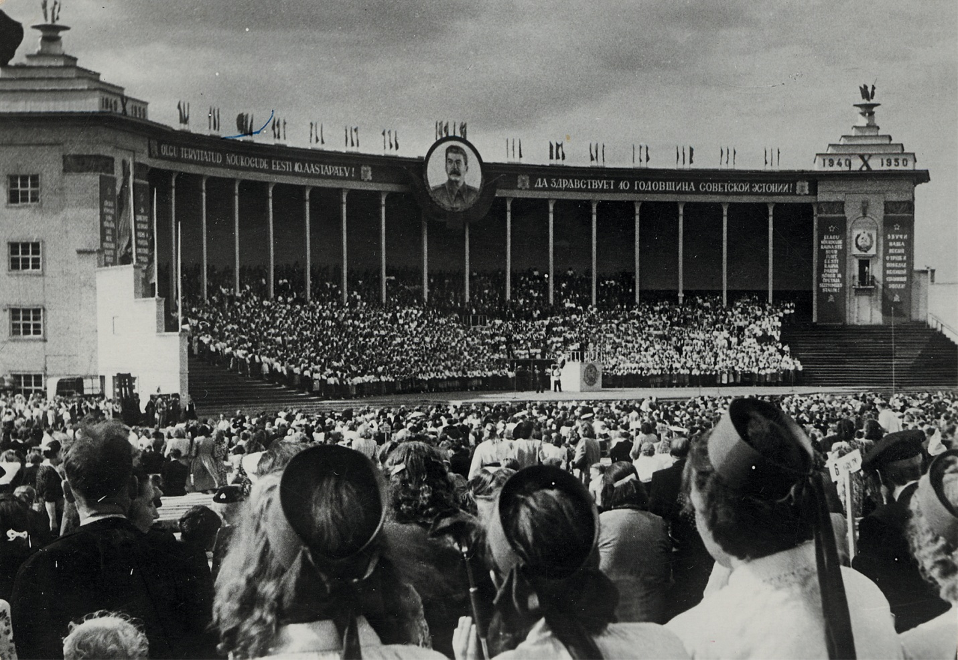
Document 4

- A major theme within The Singing Revolution is of Estonia’s preservation of its identity through culture. What evidence do you see of this in the image above?

- What evidence do you see of Soviet oppression and dominance? What evidence do you see of resistance to Soviet control?

Document 5
Excerpts from Speeches at the Hirve Park Demonstration (1987)

“Dear Estonians! We've talked a lot; now it's time to get down to work. The first thing we can do is to organize an initiative group to pursue the erection of a monument to the victims of Stalinist terror!”

“We cannot enter a just future if we do not understand the mistakes that were made, and if we do not propose to the successors of the German Reich (the Federal Republic of Germany and the German Democratic Republic) and to the government of the Soviet Union, that they renounce the Molotov-Ribbentrop Pact and its additional secret protocol.”

“We must disclose honestly the history of our people. Many things must be re-evaluated in the process. All crimes against humanity must be resolutely condemned. Stalinist executioners, many of whom are collecting a government pension today, must be put on trial!”
Only then can we be sure that all this will never be repeated.”

“The secret deals of the Molotov-Ribbentrop Pact of August 23, 1939 must be publicized!”

- What were the main concerns of Estonians addressed in the excerpts above?

- What do these concerns indicate about the approach Estonians were going to take to rid themselves of Soviet influence? Were the Estonians advocating open rebellion?

- How do the statements at Hirve Park appeal to claims of injustice?

Document 6

1988 SOVEREIGNTY VOTE
In November of 1988, the Estonian Supreme Council (the official Communist governing body of
Estonia) voted that Estonian laws would take precedence over those laws coming out of Moscow. Gorbachev was infuriated.

1989 REPUBLIC OF ESTONIA CITIZENS’ REGISTRATION
In 1989, Estonian activists started registering citizens of the Republic of Estonia, an act that essentially declared the Soviet occupation to be illegal under international law. Remarkably,
860,000 people registered…nearly every adult in the country.

1990 Message from the Conference of the Estonian Citizens' County Committees to Citizens of the Republic of Estonia and to All Residents of Estonia
Citizens of the Republic of Estonia! We invite you to participate in the elections for the Congress of Estonia! Let us elect trustworthy representatives who will express our will on the issue of Estonian national independence!

Texas

- In your own words, summarize three actions Estonians took, in 1989 and 1990, to gain independence.

- Was Estonia free from the Soviets between 1989 and 1990? Did they have the legal right to carry out the activities in the document? Did they have any right to carry out these activities?
Mexican Cession

Texas
Mexican Cession

